1. **Install Java** 
   * yum install java >>>>> tab tab
   * yum install java-11-amazon-corretto.x86_64
2. **Create a Folder**
   * cd /mnt
   * mkdir server
   * cd server
3. **Download aapache tomcat**
   * wget <https://dlcdn.apache.org/tomcat/tomcat-9/v9.0.89/bin/apache-tomcat-9.0.89.zip>
   * unzip apache-tomcat-9.0.89.zip
   * rm -rf apache-tomcat-9.0.89.zip
   * chmod -R 777 apache-tomcat-9.0.89/
   * cd apache-tomcat-9.0.89/
   * cd webapps/
4. **Download the Jenkins war file**
   * wget https://get.jenkins.io/war-stable/latest/jenkins.war
   * ls -ltr
   * cd ../../
   * cd bin
   * ./startup.sh
5. **Git**

* Create repo_1 repository >>>> in github
* In linux –
* yum install git -y
* create repo_1 folder –
* mkdir repo_1
* cd repo_1/
* git init
* git config -- global user.name
* git config ­-- global user.email
* vi index.html >>>> this is repo 1
* git add index.html
* git commit –m “this is the first commit”
* git remote add origin (repo_1 URL)
* git push origin master

With this above method repo_2 and repo_3 folder was created and push to the repo_2 & repo_3 remote repositories with index.html file init.

1. **Jenkins**

* Job 1: Repo 1
* Execute Shell
  + - * Yum install httpd –y
      * Service httpd start
      * Cp index.html /var/www/html/
      * Chmod –R 777 /var/www/html/ >>> Apply & Save
      * Build the Job 1

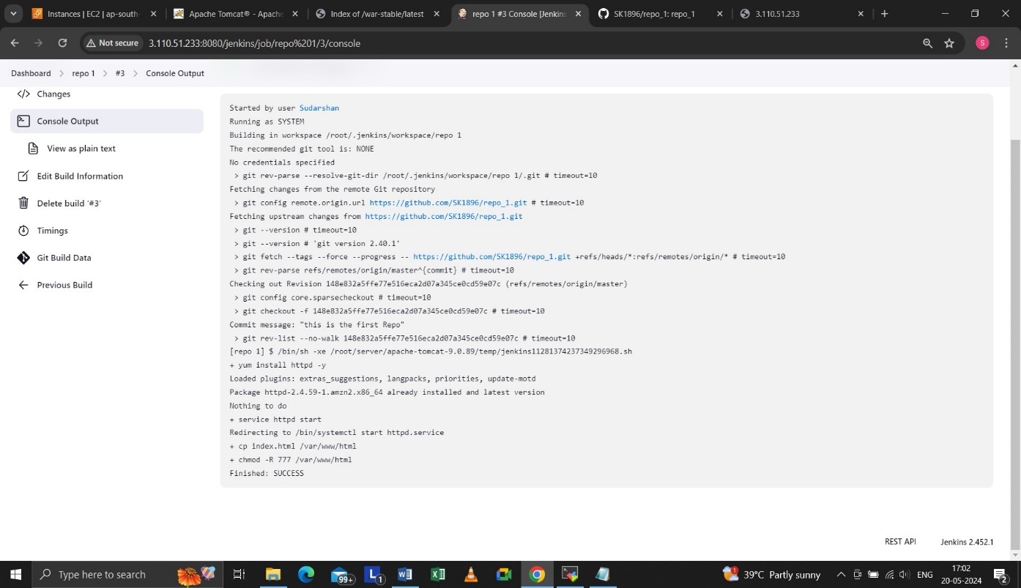

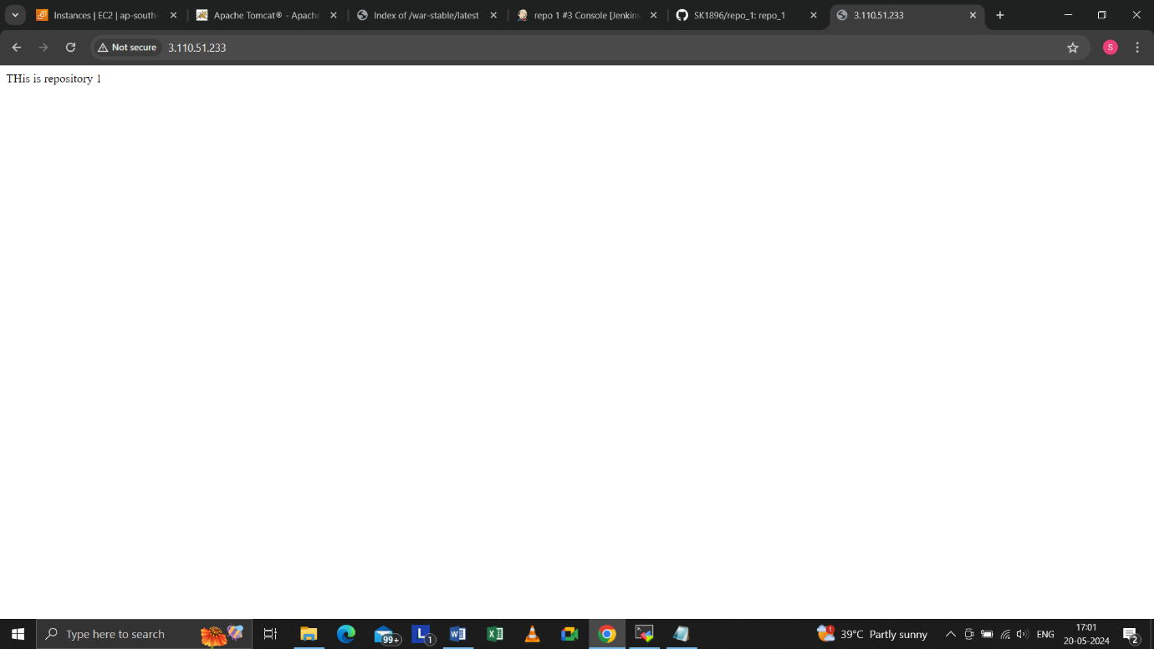

* Job 2: Repo_2
* Execute Shell
  + - * Yum install httpd –y
      * Service httpd start
      * Cp index.html /var/www/html/
      * Chmod –R 777 /var/www/html/ >>> Apply & Save
      * Build the job 2

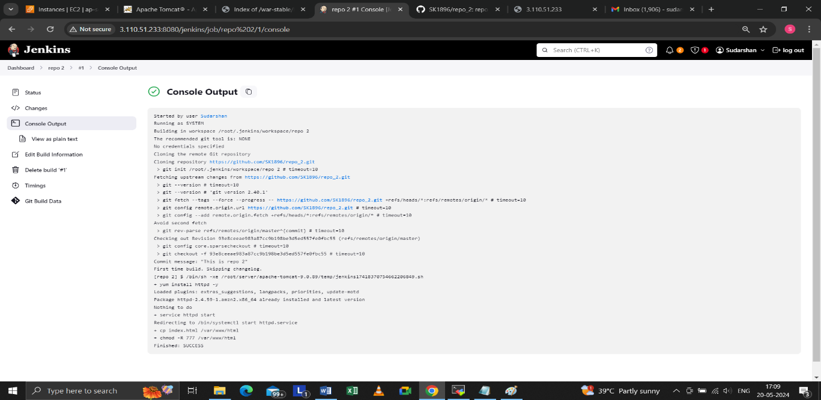

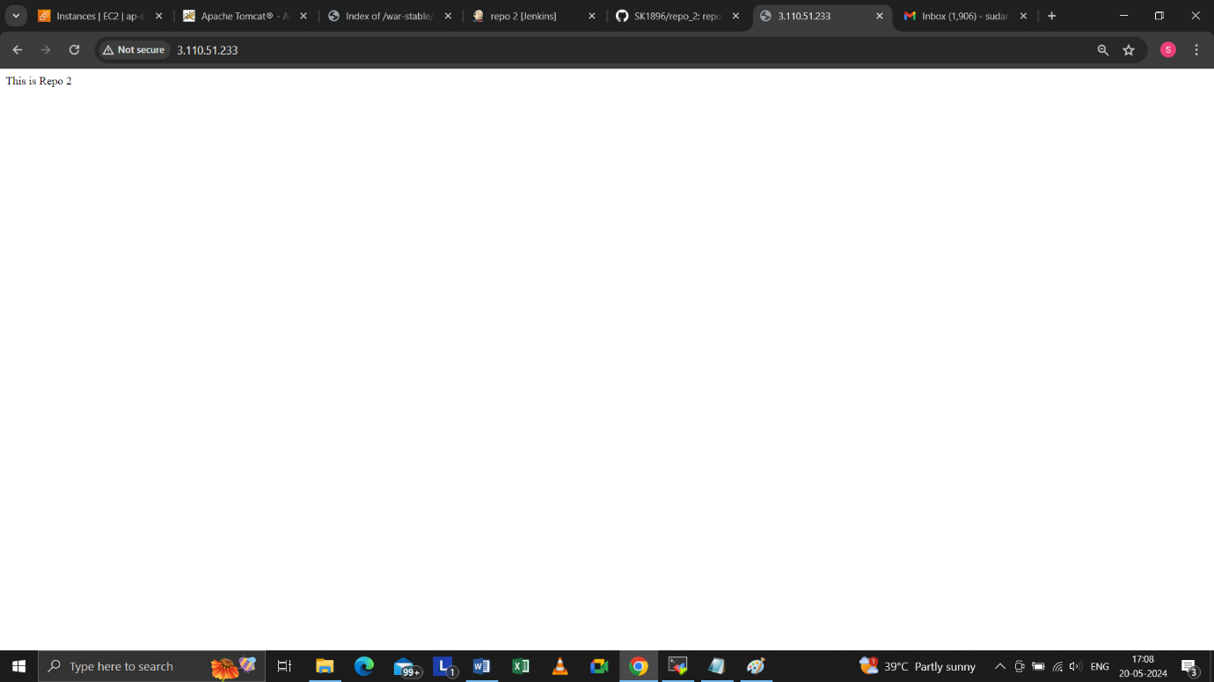

* Job 3: Repo 3
* Execute Shell
  + - * Yum install httpd –y
      * Service httpd start
      * Cp index.html /var/www/html/
      * Chmod –R 777 /var/www/html/ >>> Apply & Save
      * Build the job 3

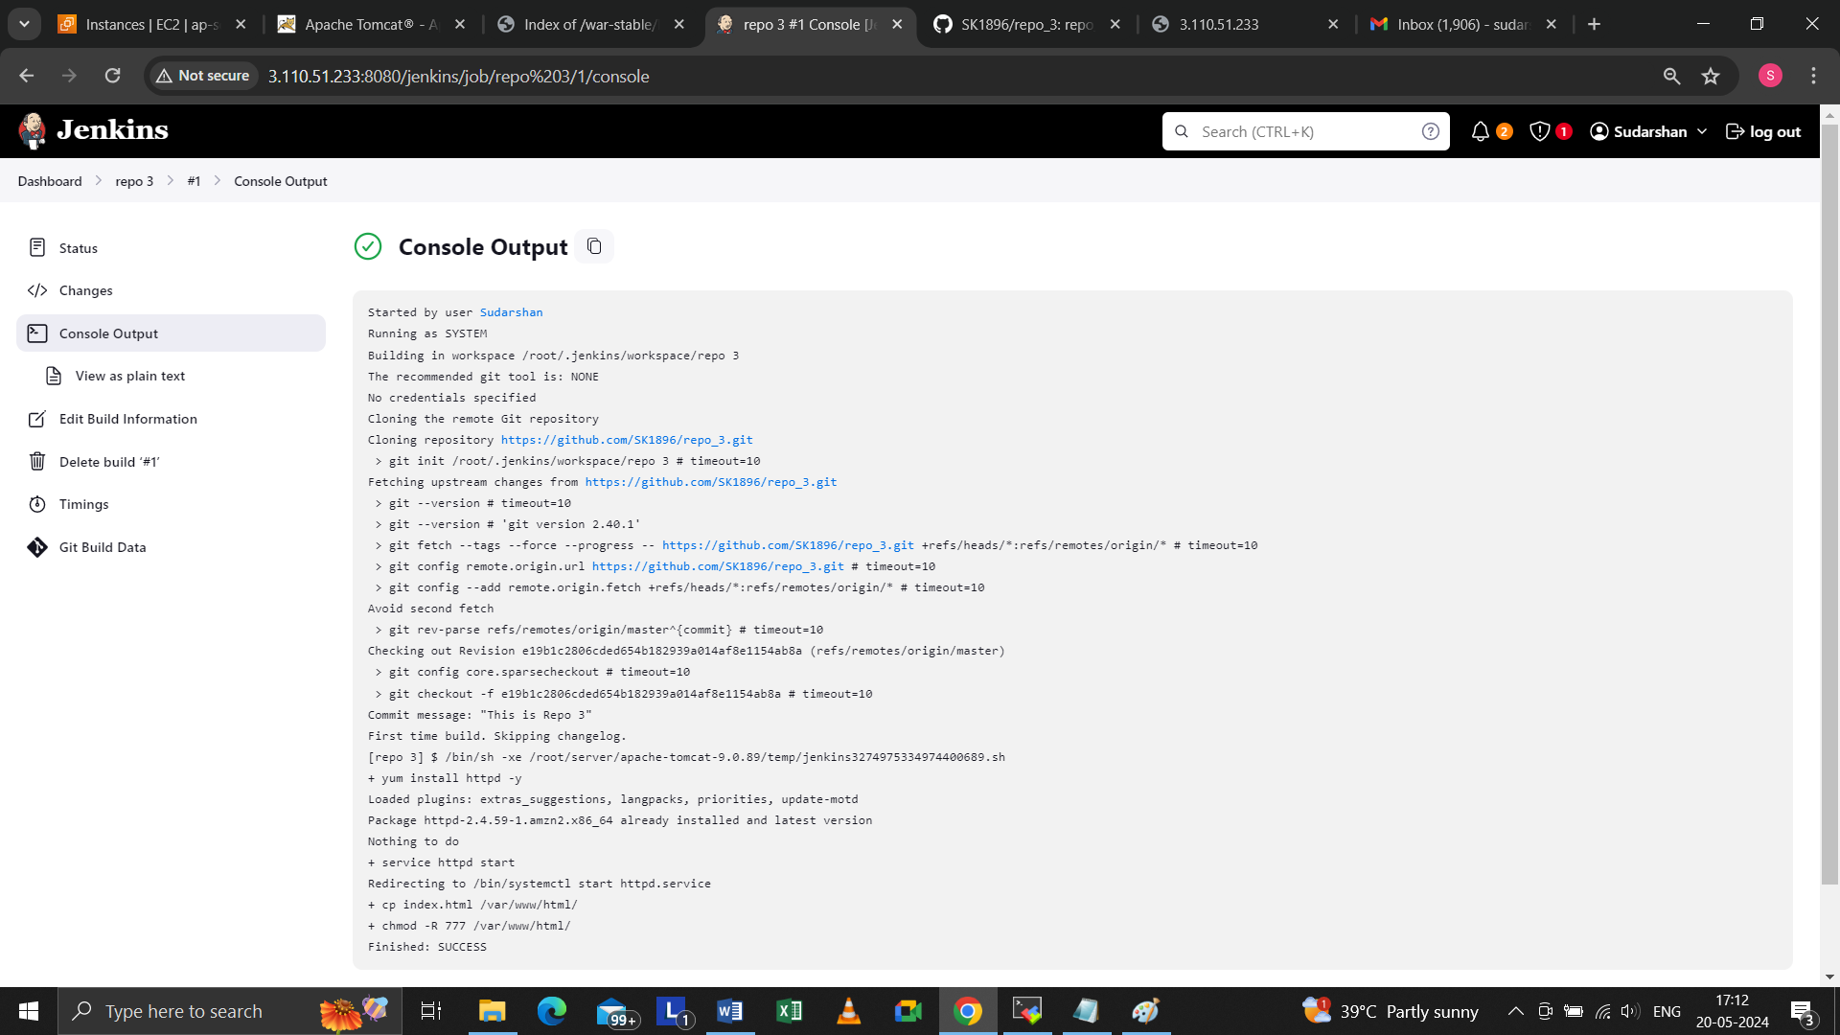

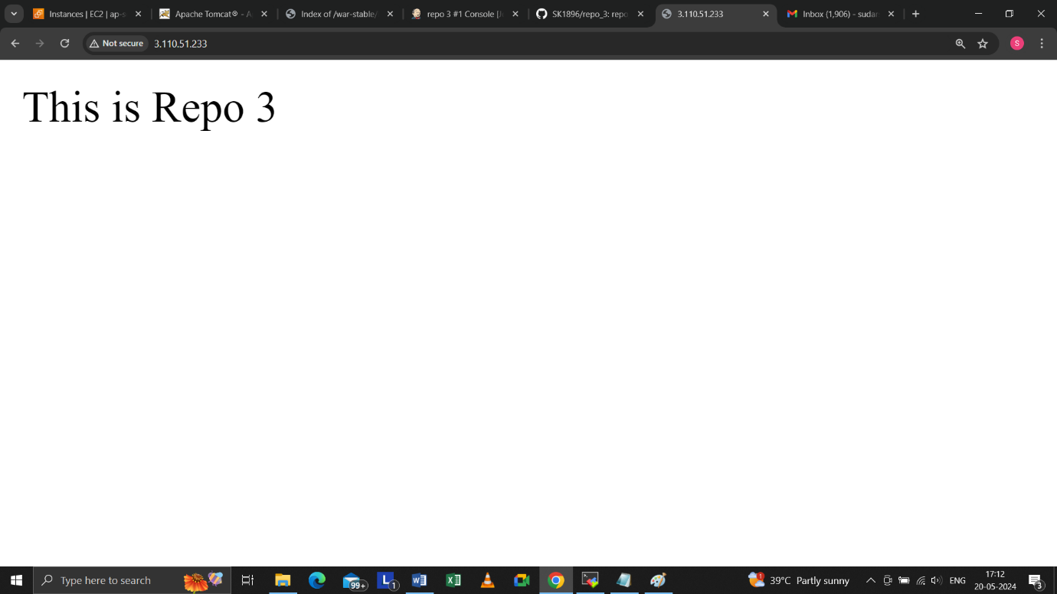

**Assignment from – Sudarshan Sandeep Kamble – 6 Jan AWS batch**